**Online Quiz**

**Given:**

A school wants to conduct online quiz for its students. Students should be able to start the quiz, get the questions, select their answers and view the results and explanations. It should be a Django web application.

**Project:**

The Online Quiz application is developed using Django. This application contains a login page followed by the quiz starting page. On clicking the start button, the user can take the quiz. If the users miss questions while attending the quiz, an alert message will be posted. Once the user answers all the questions, scores will be displayed.

The project is deployed in AWS EC2 instance. The ip address to access the website is **3.90.239.173:8000**

**Output:**

**Screen 1: Login Page**

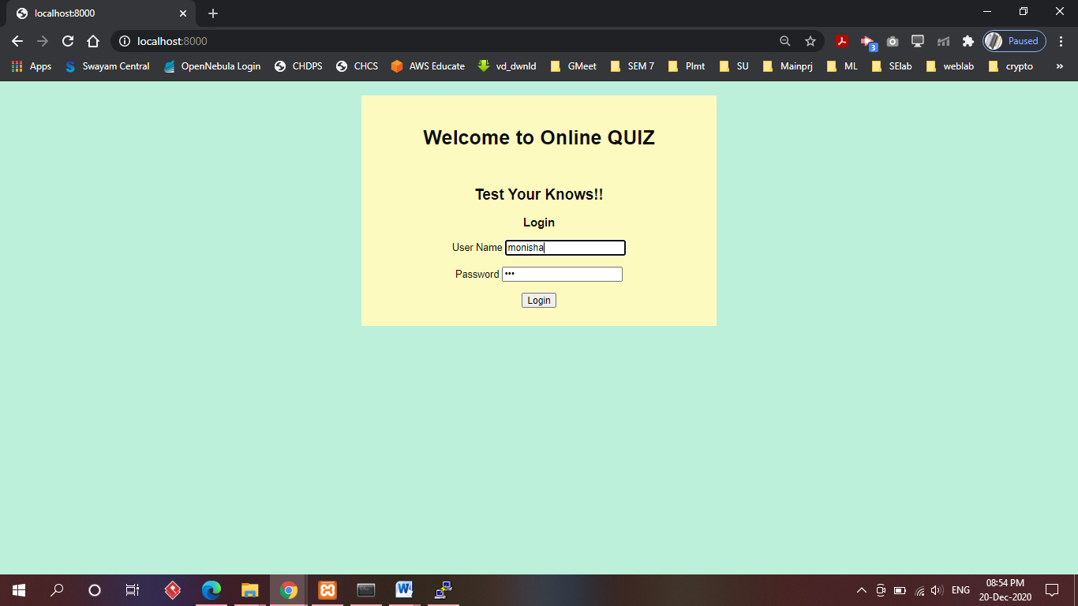

**Screen 2: Quiz Start Page**

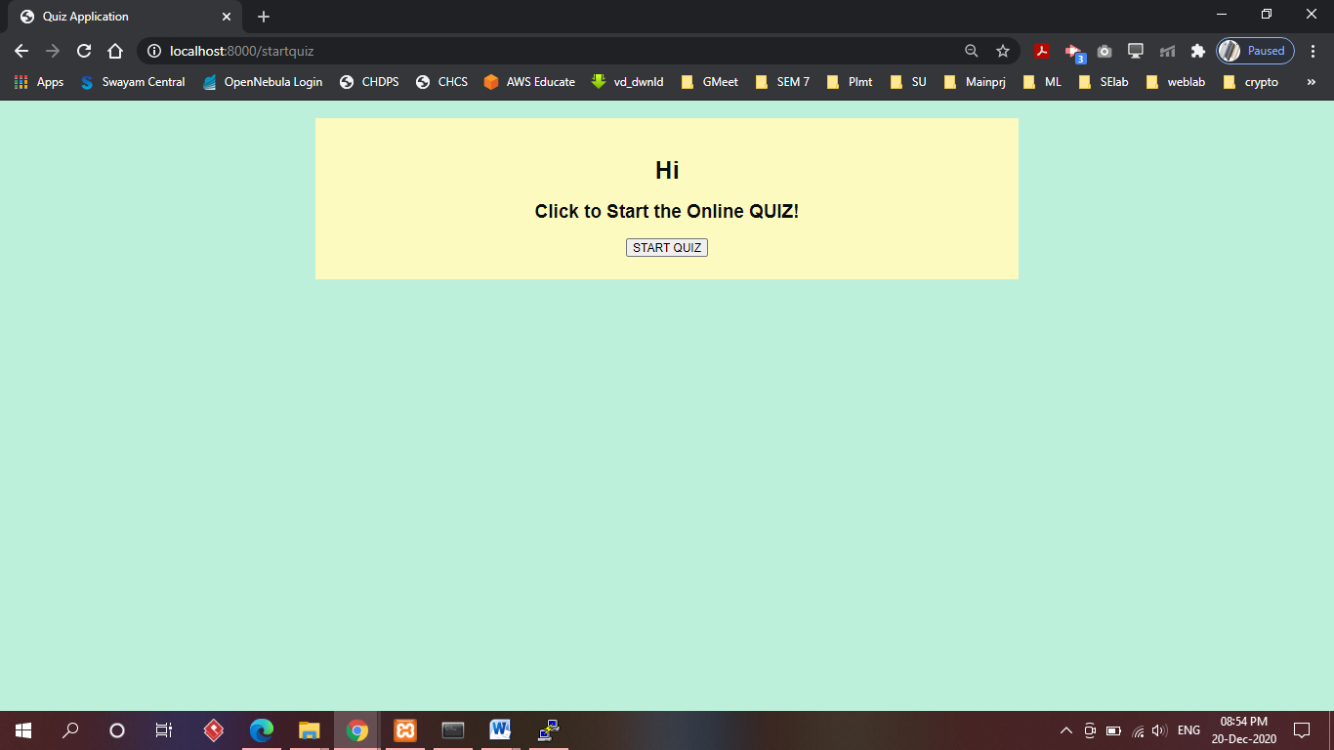

**Screen 3: Quiz Questions**

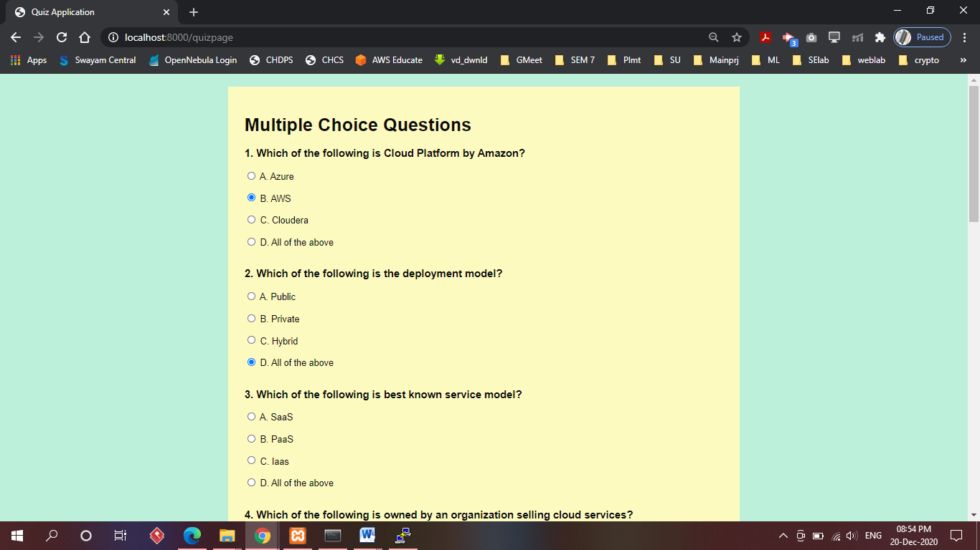

**Screen 4: Alerts for Missed questions**

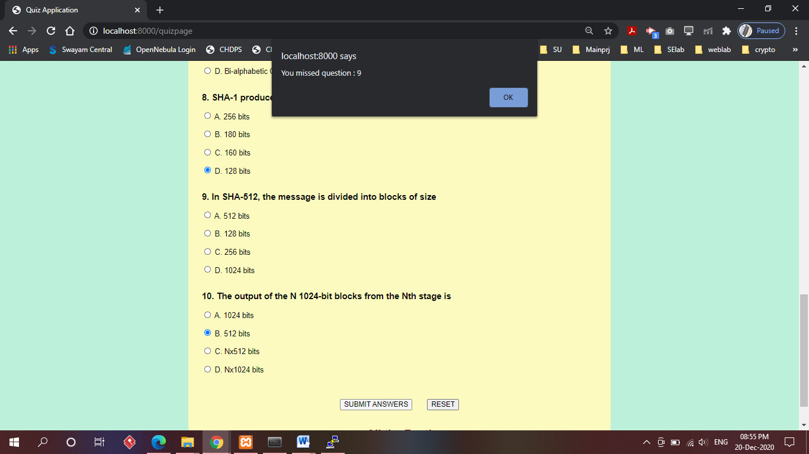

**Screen 5: Result Page**

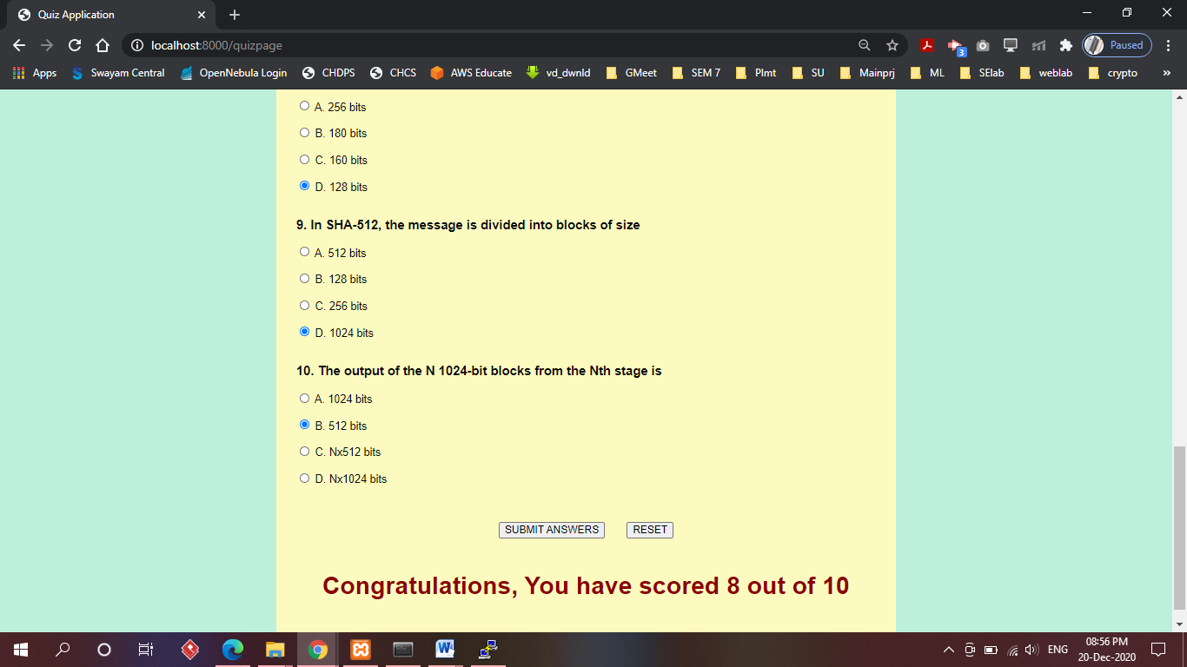

**Website accessed using AWS EC2 ip address:**

